Acknowledgement

I wish to express my deep sense of gratitude to Dr.M.Palaninatharaja, Principal of Thiagarajar College of Engineering for his support and encouragement throughout this project work.

I wish to express my sincere thanks to Dr.S.Mercy Shalinie, Head of the Department of Computer Science and Engineering for her support and ardent guidance.

I owe my special thanks and gratitude to Dr.N.Shivakumar, Designation, Department of Computer Science and Engineering for his guidance and support throughout our project.

I am also indebted to all the teaching and non-teaching staff members of our college for helping us directly or indirectly by all means throughout the course of our study and project work.

I extremely thank my parents, family members and friends for their moral support and encouragement for my project.

Abstract
Navigation technology has advanced substantially since users started utilizing satellite-based mobile programs like Google Maps, which works across platforms, and Apple Maps, which only works on Mac OS X, in place of traditional maps. The primary focus of these programs is outdoor navigation. The focus of this project is the concept of navigating indoors using augmented reality (AR). It could be difficult for people of varying ages to navigate extensive building structures. This project offers a solution to this problem utilizing accessible and widely available resources. This method makes it simple to locate a store inside a mall, a specific room in a hotel, etc. Users are also provided with relatively exact visual directions via their smartphone to get to their desired location. On their mobile phones, users will receive 3-D augmented objects that will point them in the direction of the intended site as they proceed along the path after simply providing their desired location. The user is shown the path in a real-world scenario on their devices using 3-D objects so that they can easily understand and move on. We can therefore make it simple to move around inside big buildings.

Table of Contents
Chapter No | Title | Page No
 | Abstract | ii
 | List of Tables
 | List of Figures
 | List of Abbreviations
1. | Introduction
1.1 | Augmented Reality
1.2 | Difference between AR and VR
1.3 | Applications of AR
1.4 | Indoor Navigation
2. | Literature Survey
3. | Problem Definition and Background
3.1 | Existing Approach
3.2 | Problem Statement
3.3 | Needs for Indoor navigation
3.4 | Objectives of Indoor Navigation using AR
4. | Requirements analysis and specification
4.1 | Hardware Specifications
4.2 | Software Specifications
 | 4.2.1 ARway Toolkit
 | 4.2.2 Unity
5. | Control Flow Graph (OR) System Design
6. | Proposed Approach
6.1 | Creating content for maps
6.2 | Mapping
6.3 | Localization
6.4 | Path Finding Algorithms
 | 6.4.1 Dijkstra Algorithm
 | 6.4.2 A* Algorithm
7. | Implementation
8. | Experiments and Results
9. | Conclusion and Future work
11. | References
12. | Plagiarism Report
13. | Publications

List of Tables
6.1 | Shows the execution time of Dijkstra and A* algorithm for various input values

List of Abbreviations
GPS | Global Positioning System
AR | Augmented Reality
VR | Virtual Reality
BLE | Bluetooth Low Energy
POI | Point of Interest
IPS | Indoor Positioning System

List of Figures
3.1 | Wi-Fi fingerprint-based positioning
3.2 | Illustration of Bluetooth-based positioning
4.1 | ARway toolkit
4.2 | Unity game engine and development platform
5.1 | System Design Diagram
6.1 | Design Flow Diagram
6.2 | Flow Diagram of Dijkstra Algorithm
6.3 | A graph comparing the execution time of Dijkstra and A* algorithm for input values below 12
6.4 | A graph comparing the execution time of Dijkstra and A* algorithm for input values above 12
7.1 | Unity application
7.2 | Packages installed and Environmental Setup
7.3 | Content Creation for the target location
7.4 | Steps involved in adding path finding algorithm
7.5 | DrawPath script executed in the Unity
8.1 | Markers overlaid on the real-time environment to enhance user experience

1. INTRODUCTION
Indoor and outdoor navigation has become easier than ever before, thanks to technological advancements. Traditional methods of navigation such as wayfinding and map reading were used in former times. However, with the advent of the digital era, more contemporary methods of getting to a certain destination were developed. The current digital navigation system uses a mix of hardware and software elements to give users assistance and directions for travelling across varied surroundings by utilizing digital maps, satellite positioning, and other data sources. With this system, both indoor and outdoor navigation are possible, making it one of the most sought-after technologies.
The most popular type of navigation is outdoor navigation, which often uses satellite-based positioning systems like GPS to locate the user and deliver directions. In order to compute routes, provide turn-by-turn instructions, and provide other navigation functions, outdoor navigation systems often employ digital maps and GPS data. The indoor navigation system, on the other hand, concentrates on offering navigational solutions in enclosed places where GPS signals might not be trustworthy. Wi-Fi and Bluetooth are two common technologies used for indoor navigation. Augmented reality (AR) may feasibly be used by indoor navigation systems to improve the user experience. Using the camera of a smartphone, augmented reality (AR) may overlay digital information, such as arrows or instructions, over the user's real-world view, giving visual clues for navigation.
  - Augmented Reality
Augmented reality (AR) combines digital content, such as virtual information or objects, with the physical environment in real-time to enhance perceptions of reality via devices like smartphone, tablet, wearable device, or through dedicated AR glasses or headsets. AR often represents overlaying digital material over the user's perspective of the actual environment.
There are several methods to experience AR, such as visual overlays, audio cues, and haptic feedback. Visual overlays can be 3D virtual objects, animations, films, or photos projected on the actual environment to give the user's perspective of the physical things the appearance of coexistence. Virtual voices or sounds that offer extra information or direction can be used as audio cues. Physical sensations or vibrations that are brought on by virtual objects or interactions are referred to as haptic feedback.
In contrast to virtual reality (VR), which replaces the real world with an entirely immersive digital environment, augmented reality (AR) enhances the real-world environment by superimposing digital material over it. A powerful tool for enriching real-world experiences, delivering information, and enabling new types of connection and engagement. AR also enables simultaneous user interaction with the real world and virtual content.
  - Difference between AR and VR
- AR uses digital information to overlay it on the actual world Whereas VR produces a totally digital environment where people may interact.
- As AR adds digital information to the actual environment rather than totally replacing it like VR does, it is less immersive than VR. On the other side, virtual reality (VR) totally substitutes a simulated environment for the actual one.
- VR only allows users to engage with the virtual environment whereas AR allows users to interact with both the actual world and the digital information superimposed on it.
- While VR normally needs specialized gear, such as a VR headset and controllers, augmented reality (AR) may be enjoyed using a smartphone or tablet with a camera and AR-enabled software.
- While VR is frequently used for amusement and gaming, AR is frequently utilized for utilitarian purposes including navigation, training, and visualization.
1.3 Applications of AR
There are many uses for augmented reality (AR) in a variety of disciplines and sectors. A few of the typical uses of AR includes:
- Gaming and Entertainment: Gaming and entertainment have made extensive use of augmented reality to create immersive and engaging experiences. AR games let players interact with virtual items, people, or settings in the real world by superimposing them there. This includes well-known AR games like Minecraft Earth and Pokémon Go.
- Education and Training: To generate dynamic and interesting learning experiences, augmented reality is utilized in education and training. By superimposing instructional materials like 3D models, diagrams, or simulations over textbooks, worksheets, or actual objects, augmented reality (AR) can improve student comprehension and recall of material. Using augmented reality (AR) for teaching can also recreate real-world situations for medical training, military training, or career training.
- Healthcare: Medical education, patient care, and surgery planning all make use of AR in the healthcare industry. In order to give surgeons real-time advice, improve medical education, and improve patient outcomes, AR can overlay virtual pictures, models, or data over the real-world view of the patient or surgical site.
- Social Media and Communication: Social media and communication services employ augmented reality (AR) to provide users amusing and interactive filters, stickers, or effects to improve their images, videos, or video conversations. The user's face or surroundings can be used to overlay virtual material in augmented reality to create unique and sharing experiences.
One among these applications is indoor navigation. To provide visual clues and improve the navigation experience, AR can be used to overlay navigational cues, directions, and places of interest onto the user's perspective of the actual surroundings. For instance, arrows, icons, or virtual trails may be superimposed over the real environment by augmented reality navigation apps to direct users to their destinations, making navigation simpler and engaging.
  - Indoor Navigation
It is an important task to create a navigation system not only for outdoor purpose but also for indoor navigation. People must often look for reception or map to find their required spot. Finding a particular spot in big spaces becomes a strenuous task. Sometimes they can get lost which may cost their time. Therefore, a guiding system is required to overcome this hardship. This will not only help the customers but also the employees with their maintenance tasks. This navigation guidance system can be used in large, public places and buildings like hospitals, museums, amusement parks, shopping malls, resorts, universities, airports, stadiums, arenas, parking garages and multistory buildings.
It is possible to utilize electronic devices such as smartphones or tablets to showcase augmented reality data. The real-time utilization of information in various formats is known as AR. AR and VR are distinguished by their "real time" components. AR-based indoor navigation provides directions on top of real environments that can be seen through the camera of any display device. This way the user can navigate through intricate buildings without the help of another individual or map. The indoor navigation guidance system visualizes the users with a floating context and turn by turn directions inside a building. This guidance also provides routes to safe area in the case of emergency.

2. LITERATURE SURVEY
We spend a lot of time in interior places including buildings, malls, airports, hospitals, and museums, therefore indoor navigation is essential to our modern way of life. Yet, due to the lack of GPS signals and the faintly illuminated landmarks inside complicated interior settings, navigation can be difficult. Researchers and practitioners have thus researched numerous methods for indoor navigation. Some of them includes:
- “Sheinker A, Ginzburg B, Salomonski N, Frumkis L, Kaplan BZ, Moldwin MB, A method for indoor navigation based on magnetic beacons using smartphones and tablets”. In this paper, they propose to use a range of magnetic beacons with sensors for inside navigation. It is critical to deploy beacons in the navigational zone that generate a distinguishable alternating current (AC) magnetic field. The built-in magnetometer of the phone can act as a receiver and detect the signals. Because each beacon's signal is distinct, the receiver can distinguish between them, allowing for location identification through signal recording and analysis.
- “Le Dortz N, Gain F, Zetterberg P (2012), WiFi fingerprint indoor positioning system using probability distribution comparison”. In this study, Nicolas and his co-researchers utilize probability distribution comparison to describe how Wi-Fi fingerprinting might be used for indoor navigation. In a structure, fingerprints are well-known spots or landmarks. Wi-Fi fingerprinting makes use of the MAC address and Wi-Fi signal intensity. At certain locations across the structure, fingerprints are gathered during an offline period. The radio map is the name of this database. The online mode entails a comparison between the radio map's probability distributions and the existing Wi-Fi fingerprint probabilities. Utilizing a weighted mean of the three most suitable offline locations that are in agreement with the online data, the whereabouts of the user can be estimated.
- “Bakka Naveen Kumar, Mrs.P.Saranya, Keshav Bindra, Enhancement of navigation technology using augmented reality”. In this research paper they have produced an interior navigation system that leverages machine vision system and augmented reality to provide people with a means to independently traverse large buildings, no longer requiring the assistance of others to ask for directions or refer to the maps installed indoors.
- “A Survey of Indoor Positioning and Navigation Systems for Smartphones and Tablets" by Yeap, W. K., et al. (2017). The indoor positioning and navigation systems, are the main topic of this survey report. It provides an overview of several technologies, including Bluetooth, Wi-Fi, and magnetic field-based techniques, and evaluates the benefits and drawbacks of each for indoor location and navigation.
- “W. Chai, C. Chen, E. Edwan, J. Zhang and O. Loffeld, 2D/3D indoor navigation based on multi-sensor assisted pedestrian navigation in Wi-Fi environments”. Wi-Fi and a barometer sensor integrated system can also be used for indoor navigation, which can aid with better navigation performance by determining the height of a multi-story building, which is helpful while utilizing stairs. This system has the problem of being rather expensive due to the installation of barometers with Wi-Fi at various locations throughout the structure.

3. PROBLEM DEFINITION AND BACKGROUND
Due to the absence of GPS signals, the difficulty in seeing landmarks, and the complicated and dynamic inside settings, indoor navigation can be difficult. It's possible that conventional techniques like maps, signage, and floor plans don't always provide reliable and understandable navigational assistance. People may find it challenging to move about in strange interior settings as a result, which can cause inefficiency, discomfort, and even safety issues.

3.1 Existing Approach
Some of the existing techniques which aids with indoor navigation includes,
- Wi-Fi Fingerprinting Interior Navigation: In recent years, numerous journal findings have suggested various concepts for building indoor positioning systems using the available existing Wi-Fi. These concepts and systems typically divide the positioning process into two components: The initial step is the offline mode training period, which consists of collecting fingerprints (by recognizing signal strength) at specified positions in the interior area called reference points (RP) and constructing a database system to save the collected fingerprints. Then, the machine examines the intensity of the Wi-Fi signal in real-time at particular points during the second stage, also known as the evaluation stage, and contrasts it with the remembered details from the radio-map data to decide the user's location. This fingerprinting technique can be implemented programmatically and does not require the installation of new network devices. The first system to employ the two-phase fingerprinting technique was RADAR, created by Microsoft, and it had an accuracy of up to three meters.
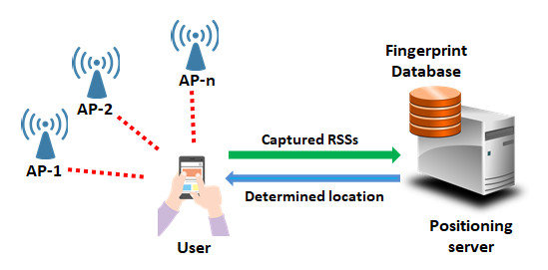
Figure 3.1 Wi-Fi fingerprint-based positioning

Advantages of Wi-Fi interior navigation:
- Wi-Fi IPS can enable precise indoor location with a few metre precision.
- Buildings have a lot of Wi-Fi infrastructure, which makes it simple to install a Wi-Fi IPS system in an existing structure. The only extra infrastructure required are access points.
- As Wi-Fi IPS makes use of existing Wi-Fi infrastructure, it can be more affordable than alternative indoor positioning system.

Disadvantages of Wi-Fi interior navigation:
- Signal interference may have an impact on the Wi-Fi IPS's accuracy.
- Wi-Fi IPS may consume a lot of power, particularly on mobile devices where Wi-Fi must always be on to offer continuous position monitoring.
- Users may be concerned about their privacy because Wi-Fi IPS necessitates continual location data transmission from Wi-Fi enabled devices.

- Bluetooth-based positioning: It is also possible to employ Bluetooth technologies, such as Bluetooth Low Energy (BLE), for indoor locating. BLE beacons, which are compact, low-power transmitters of signals, may be positioned in predetermined areas of an interior space. After receiving and processing these signals, the user's device can infer the user's location based on the beacons' proximity and signal strength.
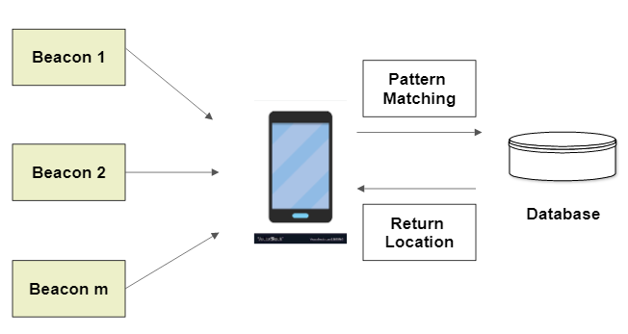
Figure 3.2 Illustration of Bluetooth-based positioning

Advantages of Bluetooth-based positioning:
- With an accuracy of up to a few metres, Bluetooth positioning may give precise indoor location. Its accuracy is similar to Wi-Fi IPS accuracy.
- For Bluetooth positioning, which is a low-power wireless technology that saves energy on mobile devices, Bluetooth Low Energy (BLE) technology is frequently utilized.
- A Bluetooth positioning system may be easily implemented in existing structures since Bluetooth technology is commonly used on mobile devices.
- As Bluetooth positioning makes use of the existing Bluetooth infrastructure, it can be more affordable than alternative indoor locating systems.

Disadvantages of Bluetooth-based positioning:
- The normal range of Bluetooth location is 10 to 20 metres. For certain interior navigation applications, this range could be enough, but not for places that are much bigger.
- Signal interference from obstructions and the presence of other Bluetooth devices or access points can reduce the precision of Bluetooth location.
- Users may be concerned about their privacy since Bluetooth positioning necessitates continual location data transmission from Bluetooth enabled gadgets.

- Inertial sensors-based positioning: Based on the motion and orientation of the user's device, inertial sensors like accelerometers, gyroscopes, and magnetometers can be used to determine the user's position. This method generally entails integrating the sensor data over time to calculate the user's orientation and location while accounting for acceleration, rotation, and changes in the magnetic field.

Advantages of Inertial sensors-based positioning:
- Accurate indoor positioning with an accuracy of up to a few millimetres is possible with inertial sensor-based positioning. Its precision outperforms Bluetooth positioning and Wi-Fi IPS.
- Real-time positioning data is provided via inertial sensor-based positioning, making it appropriate for applications that need immediate response.
- Signal interference has no impact on location based on inertial sensors, making it appropriate for situations where signal interference is a problem.
Disadvantages of Inertial sensors-based positioning:
- Drift error affects inertial sensor-based location, which may worsen over time and lower accuracy. The inertial sensors' innate characteristics are to blame for this inaccuracy.
- Initial calibration is necessary for inertial sensor-based positioning to take sensor offset and faults into account. This calibration can take some time, and it might need to be done again and again.
- Particularly on mobile devices, inertial sensor-based positioning can consume a lot of power because the sensors must be always active to enable real-time location monitoring.

- Ultrasonic-based positioning: The time of propagation of ultrasonic waves between transmitters and receivers positioned at known locations inside an environment may be measured using ultrasonic sensors. Based on the distance between the user and the transmitters/receivers, the position of the user may be calculated by detecting the time delay of ultrasonic waves.

Advantages of Ultrasonic-based positioning:
- Because it doesn't rely on existing infrastructure, ultrasonic-based positioning is appropriate for settings where infrastructure-based methods are unavailable.
- Ultrasonic positioning offers real-time positional data, making it appropriate for uses that need immediate response.
- Compared to radio waves used for Wi-Fi IPS and Bluetooth positioning, ultrasonic waves are less sensitive to interference from objects and other devices.

Disadvantages of Ultrasonic-based positioning:
- Positioning with ultrasonic has a finite radius.
- It can be difficult to maintain a direct line of sight between the transmitter and receiver in areas with obstructions or intricate buildings when using ultrasonic-based location.
- Due to the limited availability of ultrasonic transmitters and receivers in mobile devices, ultrasonic-based locating in existing structures is challenging to apply.

- Dead reckoning: With the help of motion data, such as step count, stride length, and direction, dead reckoning continually updates the user's position depending on their movement. It first guesses their location based on their original position and orientation. To reduce mistakes, this strategy needs precise motion sensing and calibration.

Advantages of Dead Reckoning:
- Dead reckoning is a reasonably straightforward navigational technique that just needs the most fundamental tools and computations.
- Dead reckoning, as opposed to techniques that rely on irregular updates from outside sources, enables continuous monitoring of a moving object.
- Dead reckoning can be used in cases when external sources of information, such as GPS signals or radio beacons, are unavailable or incorrect since it is not dependent on them.
- Given that it doesn't need on costly equipment or membership fees, dead reckoning can be a financially sensible kind of navigation.
Disadvantages of Dead Reckoning:
- If the object's speed or direction are estimated incorrectly, or if the object's movement is influenced by outside forces like wind or currents, dead reckoning may not be accurate.
- Dead reckoning is based on prior measurements and locations, which might contain mistakes over time that result in large departures from the true position.
- As inaccuracies can quickly mount over larger distances, dead reckoning is only useful over short distances.
- Dead reckoning can lead to being lost or bewildered if the beginning position is not known with precision or if the item deviates greatly from its planned route.

3.2 Problem Statement
Indoor navigation may be difficult and time-consuming for people, including visitors, patients, and employees, especially in complex indoor locations like huge retail malls, airports, hospitals, or office buildings. Using outdated information and being difficult to follow, traditional navigation techniques like paper maps and signs can cause confusion, delays, and discomfort.
Augmented Reality (AR) technology, which allows users of a device like a smartphone or smart glasses to overlay digital information such as maps, instructions, and places of interest onto the real-world surroundings, is one possible answer to this issue. Users of AR-based indoor navigation systems may get personalized, context-aware, and real-time navigation directions, which would improve their navigational experience and increase their ability to quickly and correctly locate their intended destinations.

3.3 Needs of Indoor Navigation
- Maneuvering through extremely intricate architectural structures.
- To always find a method to reach where you're going and to avoid getting lost.
- Locating yourself precisely so that you may let friends and family know you're there.
- Finding a particular spot in big spaces is a strenuous task.
- Guiding mechanism for navigating to the specified location quickly and by the quickest path.

3.4 Objective of Indoor Navigation using AR
- To give precise directions along the path.
- To reduce the time needed to locate a spot inside complex building.
- To improve efficiency in the event of heavy foot traffic.
- To aid people in getting to their destinations swiftly when they have essential responsibilities.

4. REQUIREMENTS ANALYSIS AND SPECIFICATION
With the introduction of augmented reality (AR), indoor navigation has undergone a revolutionary change, opening up promising potential for improving user experiences in intricate interior surroundings. A successful AR indoor navigation system must have crystal-clear user criteria that reflect the demands of the intended users. The user requirements provide the basis for creating and putting into use a successful AR indoor navigation system. Some specifications for users include:
- Real-Time Navigation: Users of the AR indoor navigation system must be able to see their current position, direction, and route on a live video stream utilizing AR overlays, providing them with real-time navigation advice.
- Point of Interest (POI) Identification: AR indoor navigation system must be able to recognize and show pertinent points of interest on the user's AR display, such as exits and elevators.
- Robust Tracking and Positioning: The AR indoor navigation system must track and position the user's location and heading in real-time with accuracy and dependability.
- User-Friendly Interface: The user interface of the AR indoor navigation system must be simple to use, with easy-to-understand buttons and obvious visual clues.
4.1 Hardware Specifications
A promising technology that enables users to explore and engage with interior settings in an immersive and engaging way is indoor navigation utilizing augmented reality (AR). Finding the right hardware requirements is a crucial step in building a successful AR indoor navigation system. The hardware, which includes the type of device, processing power, display quality, sensors, battery life, networking choices, and durability, is essential to the functionality and usefulness of the system. Some essential hardware requirements include:
Device Type: Smartphone or tablet
- The system will be created to function on widely used Android-powered smartphones and tablets.
Processing Power:
- For seamless performance, a minimum quad-core processor and at least 4 GB of RAM are required.
Display Quality:
- A screen with a minimum resolution of 1080 pixels.
- For convincing AR overlays, good color accuracy, brightness, and contrast are essential.
Battery Life:
- 6 hours minimum of nonstop use is required for uninterrupted navigation.
Connectivity:
- Cellular data for real-time map downloads and updates.
Form Factor:
- Smartphone or tablet form factor for easy handling and portability.
4.2 Software Specifications
- ARway Toolkit
- Unity
4.2.1 ARway Toolkit
The software development kit, ARway Toolkit offers information and tools for creating augmented reality based interior navigation applications.

Figure 4.1 ARway toolkit

The ARway Toolkit for indoor navigation has the following main characteristics and specifications:
- Indoor Mapping and Localization: The mapping and localization features in the ARway Toolkit allow programmers to make and maintain indoor maps, floor plans, and POIs. The toolkit enables quick integration of unique map data or works with already-available mapping services. Moreover, it offers tools for establishing routes, generating POIs, and maintaining navigational pathways.
- Navigation and Wayfinding: With the help of ARway Toolkit's navigation and wayfinding features, users may move around indoor spaces by following AR-based visual signals like arrows or trails superimposed on their live camera feed. The toolbox enables turn-by-turn directions and real-time route computation.
- Customization and Personalization: The navigation experience may be customized and personalized using ARway Toolkit by establishing preferences for routes, POI categories, and display choices.
- AR Visualization and User Interface (UI): To improve the user's navigation experience, ARway Toolkit provides a range of AR visualization choices, including 3D models, animations, and overlays. It offers an adaptable UI framework for creating user interfaces that are intuitive and engaging.
- Device Compatibility: Smart glasses, headsets, smartphones, tablets, and other AR-enabled devices are all compatible with the ARway Toolkit. It is compatible with a variety of platforms, including iOS, Android, and Unity.
- Licensing and Pricing: Depending on the needs and scope of the project, ARway Toolkit offers a variety of licensing and price choices, including free tiers, commercial licenses, and enterprise plans.
4.2.2 Unity
Unity can be a potent tool for combining the AR navigation features into a fully working application after utilizing ARway Toolkit for indoor navigation using AR. In order to create dynamic and immersive AR experiences, a variety of tools and resources are available through the well-known game engine and development platform Unity. By combining ARway Toolkit with Unity, developers can create smooth and interesting indoor navigation apps that take advantage of the rich features and capabilities of both platforms.

Figure 4.2 Unity game engine and development platform
By combining ARway Toolkit with Unity, developers can take use of the sophisticated mapping and tracking features of ARway Toolkit, such as indoor mapping and localization, while utilizing the visual and interactive capabilities of Unity to create fun and simple AR navigation experiences. The AR navigation application created with ARway Toolkit may be improved by utilizing Unity's features for handling user input, controlling animations, handling UI components, and interacting with other services or APIs.
A customized user experience can be created by adding new operations, logic, and behaviors to the AR navigation application using Unity's scripting capabilities. Users can explore and interact with inside surroundings in a smooth and engaging way due to the combination of ARway Toolkit and Unity, which offers a strong and versatile framework for building highly interactive and immersive indoor navigation apps utilizing AR. Finally, combining ARway Toolkit with Unity provides a strong method for creating AR indoor navigation systems.

5. SYSTEM DESIGN
An essential component of providing users with a smooth and simple navigation experience in interior locations is the system design for augmented reality (AR) indoor navigation. By offering visual clues, real-time directions, and an immersive experience, AR technology has the potential to transform how people navigate and interact with indoor settings. The user interface design, indoor mapping and localization, navigation and wayfinding algorithms, interaction and gestures, device compatibility are just a few of the components that make up the system design. A well-designed system may make it simple for users to move about large interior areas, locate interesting landmarks, and get where they're going quickly and without getting lost.
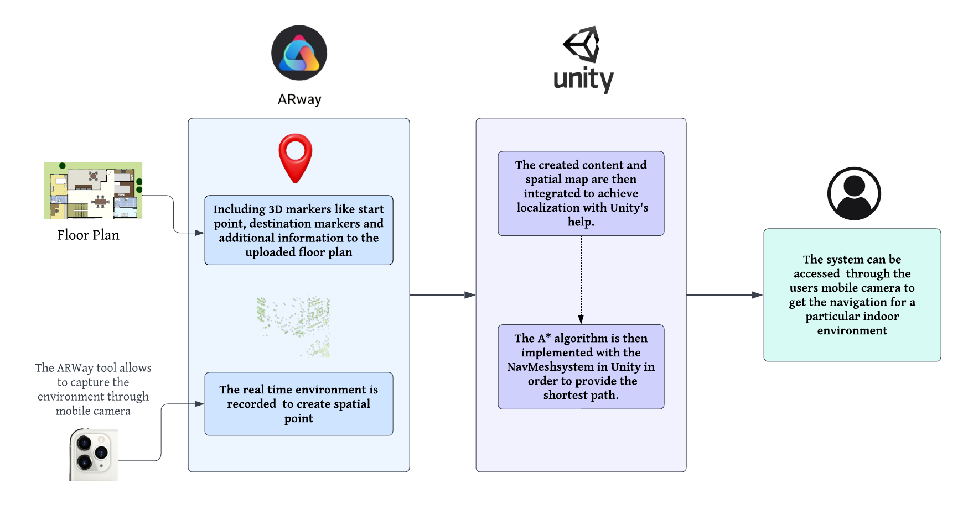
Figure 5.1 System Design Diagram
- ARway Toolkit
  - User Interaction Design
    - Adding 3D markers to the map and interactive labels for POIs.
    - Navigational cues, such as arrows or directional cues, are used as overlays on the AR view.
    - Additional textual cues are also added to direct the users effectively.
  - Indoor mapping
    - The environment is recorded in its entirety. Once the environment is recorded, the objects within it are recorded as spatial points.
    - ARway's mapping utility ensures the highest level of accuracy in mapping the physical surroundings.
- Unity
  - The created content in user interaction design phase and the spatial points recorded during mapping stage are then integrated to achieve localization with Unity's help.
  - Users must first scan the area around them before requesting for a path to be placed within the building, so that the system can identify them and then show the best way to their goal.
  - The A* algorithm can be used with the NavMesh system in Unity in order to provide the shortest path.

6. PROPOSED APPROACH
In this project, we aim to leverage augmented reality technology to create an intuitive and effective interior navigation system. Our approach involves integrating the content created and the spatial points recorded during mapping with Unity, then determining the best path-finding algorithm.
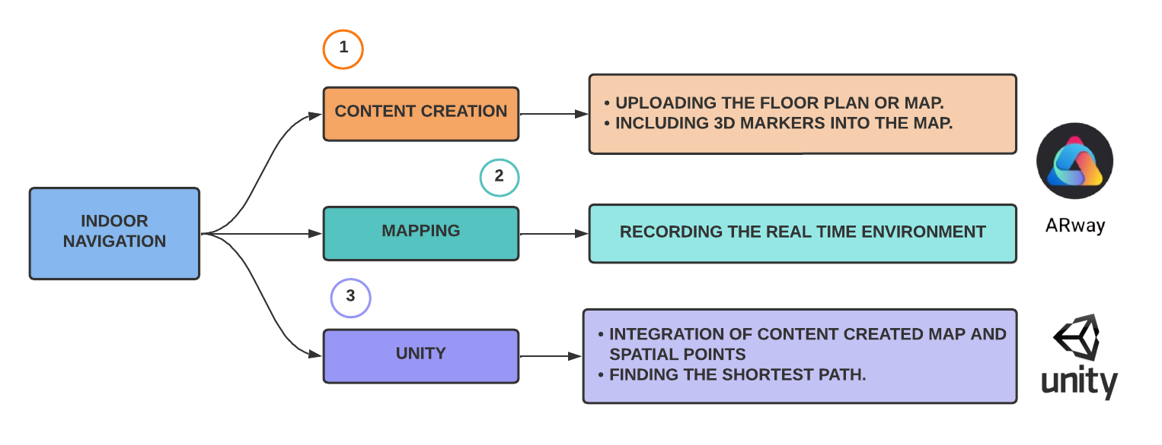
Figure 6.1 Design Flow Diagram

6.1 Creating content for maps
New map and contents for that map are created using the studio feature of the ARway tool. The details such as the map's name, description, and the kind of building for which the navigation will be designed, are given initially. Then we will proceed with producing content after creating the map. The floor plan of the building for which we are designing the navigation is necessary in order for us to create the content. When uploading the floor plan image, the floor's name and the number of floors is provided. Once the floor plan has been successfully uploaded, the origin must be determined, and then the origin of the studio and the origin of the floor plan must be made to correspond. Once the origin is specified, the web studio can be used to add information like waypoints, destinations, and necessary texts. In order to highlight the navigation path, markers are employed.

6.2 Mapping
The mapping utility that is included with the ARway tool makes it simple to map the physical surroundings. Unique features from the surroundings are gathered using real-time video mapping. The environment is recorded in its entirety. To improve mapping, every area is documented twice or three times. Once the mapping is complete, it is uploaded to cloud services. Then, with Unity's assistance, the spatial map and the developed content are combined to achieve localization and to construct an application.

6.3 Localization
Smartphone cameras can be utilized to figure out in which region of the edifice a user is situated based on their present position. To collate the image preserved in the cloud storage, computer vision can be applied. It is essential to chart the environment of all the objects that are present and store that data in the cloud database. Before requesting for a course inside the building from their spot, users have to examine the area near them in order for the system to identify their location and then illustrate the best route to their aim.

6.4 Path Finding Algorithms
To discover the most expeditious path to the goal, the Dijkstra and A* algorithms can be implemented for route locating.

6.4.1 Dijkstra Algorithm

The Dijkstra algorithm can determine the shortest route between the source node and each and every other node in the graph. The node which is least far away and hasn't been visited is chosen, and if the distance via a neighboring node is lower than the present distance, the near node's distance is revised. A node is labelled as visited once it has been visited so that the reference may locate unvisited nodes.
Step 1: Create a set to hold the unvisited set and mark all nodes as unvisited.
Step 2: Set the source node's distance to zero and overestimate the distance between the nodes with a tentative value of infinity.
Step 3: After coming across an unexplored node, figure out how far off it is now from all of its neighbours and change the distance accordingly.
Step 4: Once encountered, mark the node as visited because it cannot be visited again and remove it from the unvisited set.
Step 5: The process is finished if the target node is tagged as visited.
Step 6: If not, pick the subsequent unexplored node with the shortest distance and return to step 3 immediately.
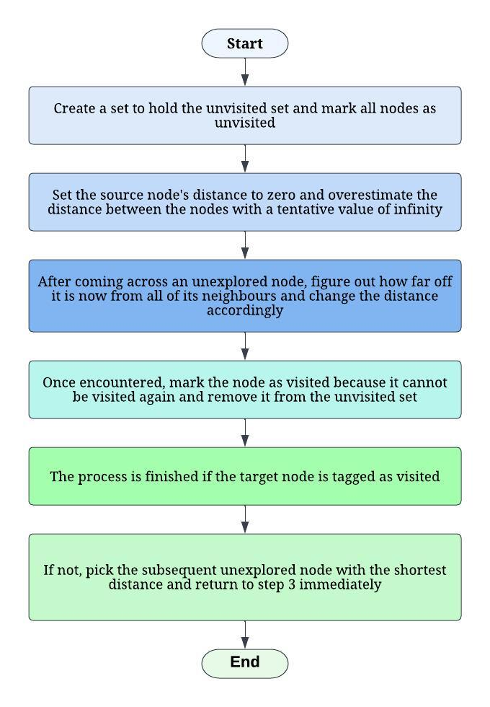
Figure 6.2 Flow Diagram of Dijkstra Algorithm

6.4.2 A* Algorithm
The A* algorithm, often known as a heuristic algorithm, is a type of informed search algorithm that employs heuristics. The most effective route between any two nodes will always be found using a heuristic function. It calculates how near the target node is and takes into account the node's present condition. It is a development of the Dijkstra method for determining the shortest path. In addition to taking the path distance into account, it also incorporates an approximate approximation while determining the shortest route. The heuristic algorithm compromises optimality for accuracy, speed, and precision to solve problems more quickly. The algorithm determines a node's distance cost from its surrounding nodes. One may compute the ultimate route cost f(n) as
If f(n) = g(n) + h(n), then
The traveling cost from one node to another is expressed as g(n), while the approximate value for the proximity of the destination node is expressed as h(n).
In order to efficiently narrow the search space and identify the best course of action, the A* algorithm combines the benefits of Dijkstra's algorithm and heuristic information. It uses a heuristic function to assess the nodes according to their estimated distance from the target node, directing the search there. The A* method would be preferable over Dijkstra's algorithm in the case of interior navigation utilizing AR since it can handle bigger indoor surroundings effectively and determine the best path. A* produces a more rapid and effective outcome. Because Dijkstra's method constantly tries to improve an initial approximation (cost) of each node, it is slower than A*.
The below table shows the execution times recorded for the Dijkstra and A* algorithms for random input values.
INPUT VALUES | EXECUTION TIME FOR Dijkstra | EXECUTION TIME FOR A*
6 | 0.000015158000169321 | 0.000009212000295519
7 | 0.000022146999835968 | 0.000007510000141337
8 | 0.000028445000061765 | 0.000023747000377625
9 | 0.000025381000014021 | 0.000023747000377625
10 | 0.000008036000072024 | 0.00000664799998048
15 | 2.6505999267101286e-05 | 1.869299914687872e-05
20 | 3.082500072196126e-05 | 1.62209989503026e-05
25 | 4.808600060641765e-05 | 1.2730001471936703e-05

Table 6.1 Shows the execution time of Dijkstra and A* algorithm for various input values

Visualizing the data in the above table allows all to easily observe how the execution times differ.
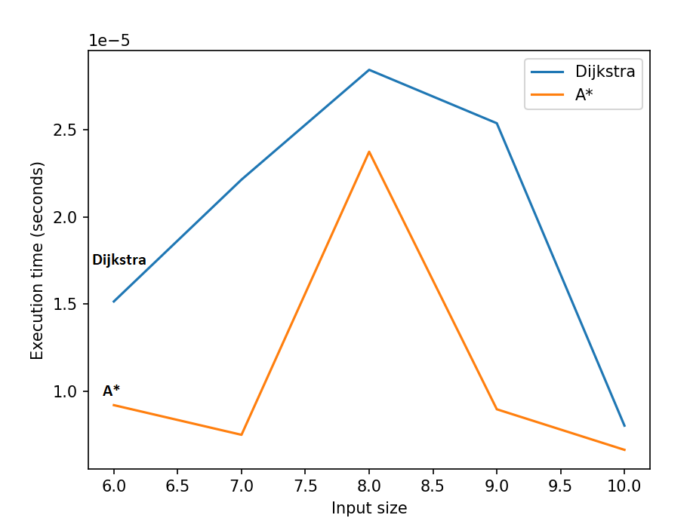
Figure 6.3 A graph comparing the execution time of Dijkstra and A* algorithm for input values below 12

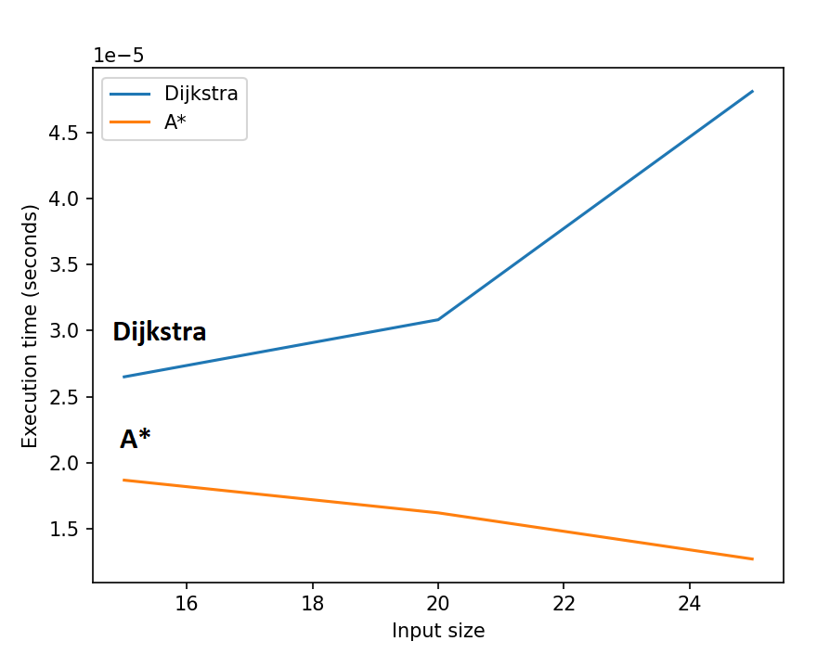
Figure 6.4 A graph comparing the execution time of Dijkstra and A* algorithm for input values above 12

The charts above suggest that the A* algorithm is quicker than Dijkstra in terms of the amount of time it needs to process different inputs. As a result, it can be deduced that A* algorithm is more efficient than Dijkstra.

7. IMPLEMENTATION
Downloading and setting up of the environment in Unity is the first and foremost step in implementing indoor navigation in augmented reality.
1) Downloading and setting up Unity
Visit the Unity download page to get the most recent Unity Hub version. Open Unity Hub after installing it on your PC. Install the Android Build Support package after installing Unity. Click the "Add" button under the "Installs" tab in Unity Hub. The "Next" button should be clicked after selecting "Android Build Support". Click "Done" after selecting the necessary Android SDK and NDK versions. Now, Unity will download and install the tools that are required to proceed with the project.


Figure 7.1 Unity application

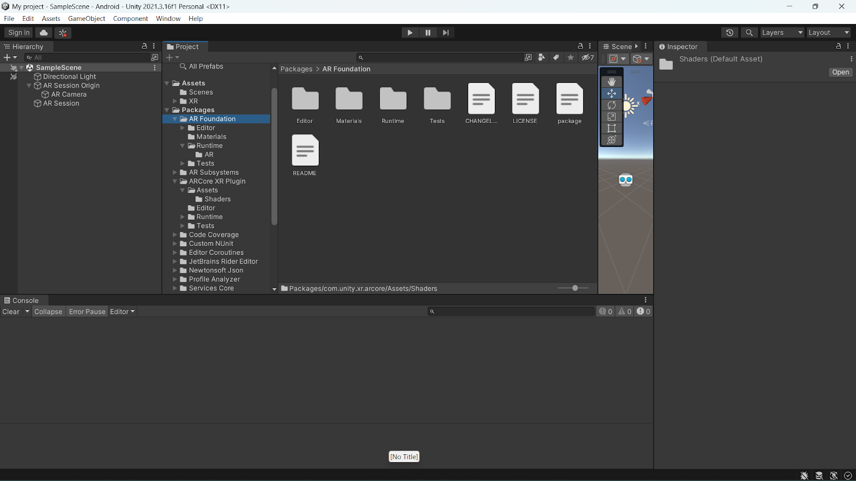
Figure 7.2 Packages installed and Environmental Setup
2) Setting up of ARway toolkit
Visit the ARway Toolkit official website and download the necessary packages from the Downloads section. Click "New" in Unity Hub to start a new project. Choose "3D" as the template, give the project a name, and a location, then click "Create." Choose "Assets" in the Unity editor, then choose "Import Package" > "Custom Package." Locate the "arway-unity-sdk.unitypackage" file in the folder containing the ARway toolkit package. Choose all of the assets in the "Import Unity Package" box and press "Import." Open the "Scenes" folder in the "ARwaySDK" folder by navigating to it in the "Assets" panel when the import is finished.
3) Adding 3D markers and waypoints
After downloading and setting up Unity and the ARway Toolkit, the next step is to create contents for the floor plan, for which we need to provide the indoor navigation. First save the preferred floor layout. We must specify the navigation pathways once the floor layout is uploaded. This entails designing paths for individuals to follow as they explore the surroundings. To aid users in staying on course, checkpoints and other markers can be placed along the routes.
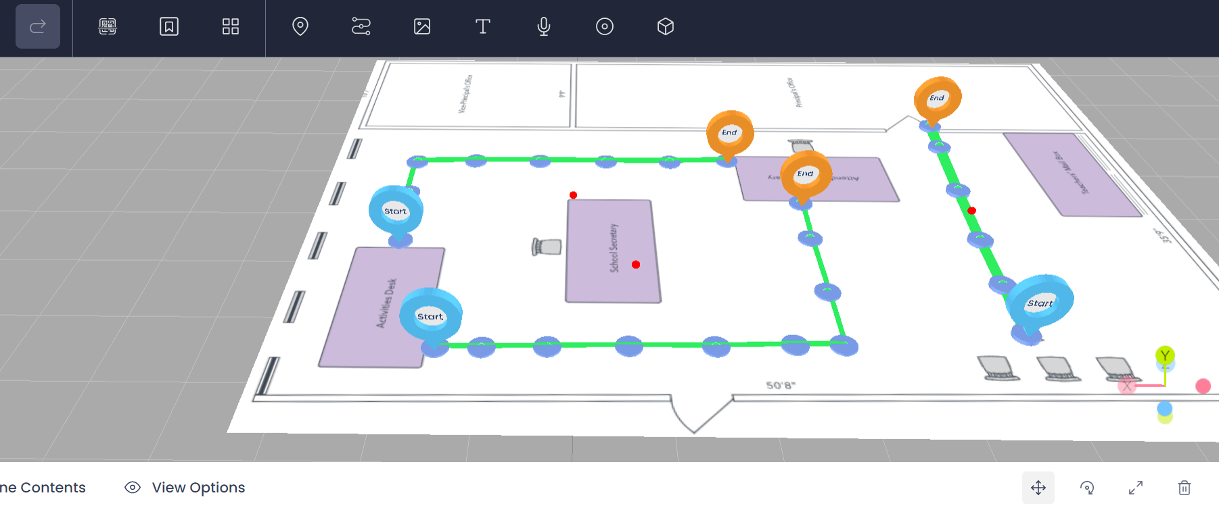
Figure 7.3 Content Creation for the target location
4) Recording of real time environment along with its object
The ARway tool includes a mapping application that makes it easy to map the actual surroundings. Real-time video mapping is used to collect distinctive characteristics from the environment. The entire surroundings are captured on film. Every region is recorded twice or three times to better mapping. The spatial map and the created content are then integrated with Unity's aid to achieve localization and create an application.
5) Path Finding
- Creating a NavMesh in the scene is the first step.
- This entails creating a NavMesh using Unity's built-in baking tools. Setting up the A* algorithm comes next.
- Either the built-in scripting tools in Unity or a third-party A* library, like the A* Pathfinding Project, can be used to implement the method.
- The graph that the A* algorithm will use to navigate the NavMesh must be defined once the algorithm has been configured.
- In order to do this, nodes and edges must be created to reflect the various routes via the NavMesh. We may execute the A* algorithm after adding the heuristic function to the set-up of the network.
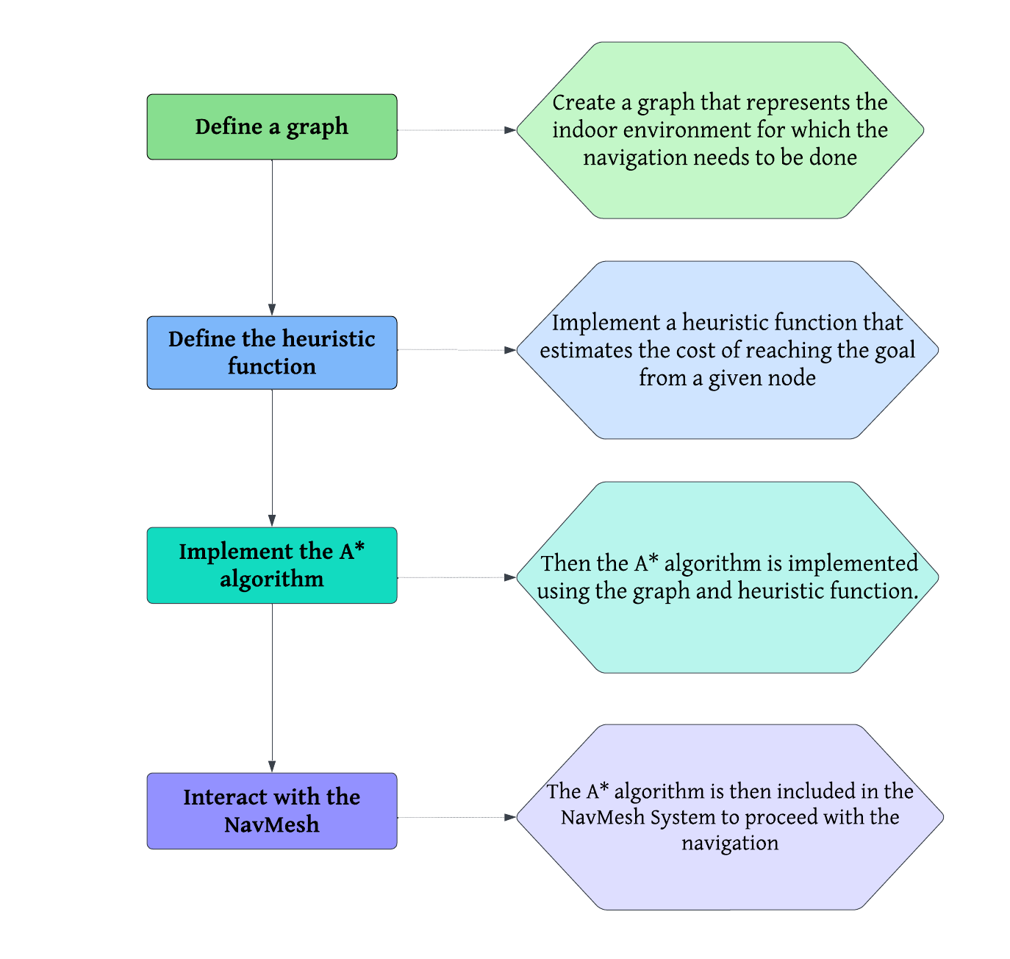
Figure 7.4 Steps involved in adding path finding algorithm

Now click the play button at the top to see if the additional components and scripts are functioning properly. A line renderer that depicts the route where the 3D markers will be shown when the user scans the environment in real time will be seen if the scripts function as intended.

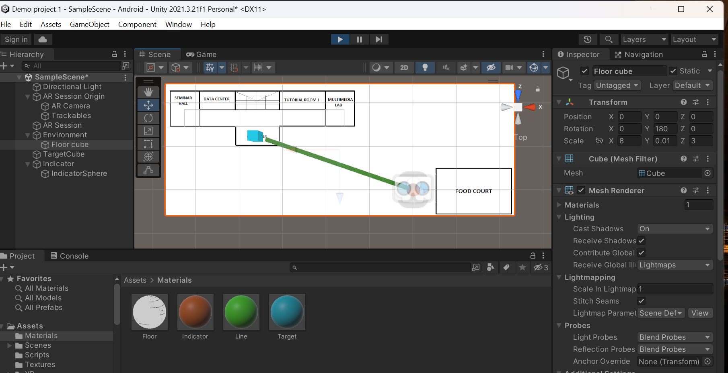
Figure 7.5 DrawPath script executed in the Unity

After completing the previous actions, select the "Build Settings" box in Unity. Choose the necessary platform in the "Build Settings" window. Be sure to adjust the target device, graphics quality, and input parameters according to the platform chosen. To create the app after specifying the options, click the "Build" button. For the platform chosen, Unity will build the required files and produce the app bundle.

8. EXPERIMENTS AND RESULTS
The indoor navigation can be achieved using various methods like Wi-Fi fingerprinting, beacon devices etc., but in comparison to those methods for indoor navigation, the A* algorithm has several benefits:
- Accuracy: Because it considers the quickest route to the target, the A* algorithm generates accurate navigation directions, whereas Wi-Fi fingerprinting and beacon devices may produce inaccuracies owing to signal interference.
- Low-cost: The A* algorithm is an affordable option for interior navigation because it doesn't need any extra hardware or infrastructure. On the other hand, beacons and Wi-Fi fingerprinting devices require expensive hardware and upkeep.
- Flexibility: While Wi-Fi fingerprinting and beacon devices might not function in some locations owing to signal strength or interference, the A* method is a versatile approach that can be utilized in a variety of scenarios.
- Real-time navigation: A* algorithm provides real-time navigation, which means that it is continuously updating the path based on the current position of the user.
Therefore, even though indoor navigation in AR may have a few minor drawbacks, it still performs better at providing users with data that is more exact. It provides a better user experience, which depends on the users receiving clear information. Indoor navigation in AR has the potential to be more interactive than existing systems.

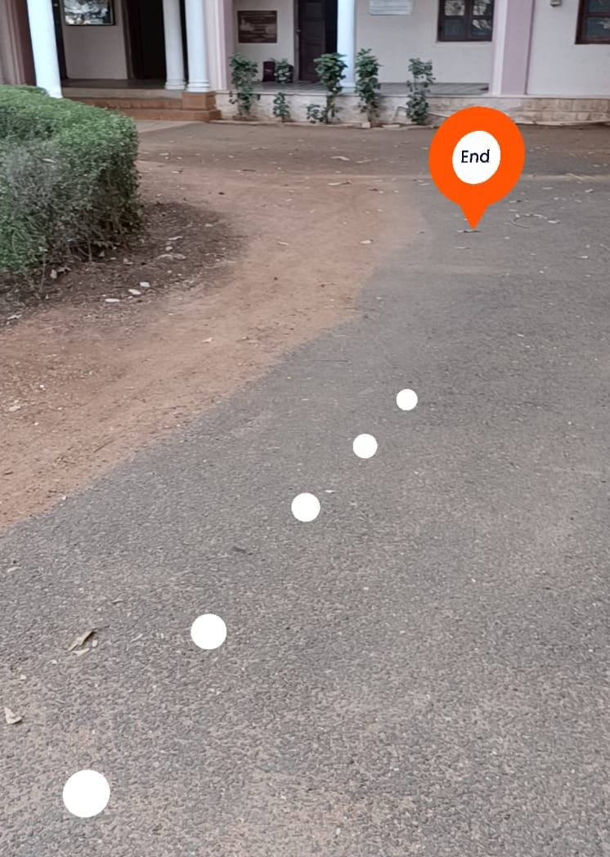
Figure 8.1 Markers overlaid on the real-time environment to enhance user experience

9. CONCLUSION AND FUTURE WORK
By giving users interactive and contextually aware visual clues, indoor navigation utilizing Augmented Reality (AR) has a lot of promise to improve navigation experiences. Improved spatial awareness, real-time information, and user involvement can all be special benefits of AR-based indoor navigation systems. The occlusion problems, and the potential for information overload are some of the obstacles that must be resolved. Future work in the field of indoor navigation using AR could focus on the areas such as improved indoor positioning, enhanced immersion techniques and inclusion of Wi-Fi indoor positioning. Personalizing the navigation experience for unique users might be the focus of future development in indoor navigation utilizing AR. This can entail adjusting navigational recommendations to each user's unique requirements and preferences utilizing information about user preferences, behaviors, and habits. Creating multi-modal navigation systems that may incorporate several forms of mobility, such as walking, cycling, or public transportation, in order to enable smooth and effective navigation in challenging interior situations is another promising field for future research.

10. REFERENCES
1. Sheinker A, Ginzburg B, Salomonski N, Frumkis L, Kaplan BZ, Moldwin MB (2016), A method for indoor navigation based on magnetic beacons using smartphones and tablets. 81:197–209. doi:10.1016/j.measurement.2015.12.023
2. Le Dortz N, Gain F, Zetterberg P (2012), WiFi fingerprint indoor positioning system using probability distribution comparison. In: IEEE ICASSP 25–30 March.
3. Bakka Naveen Kumar1, Mrs. P. Saranya2, Keshav Bindra, Enhancement of navigation technology using augmented reality. In: International Conference on Physics and Photonics Processes in Nano Science.
4. W. Chai, C. Chen, E. Edwan, J. Zhang and O. Loffeld, 2D/3D indoor navigation based on multi-sensor assisted pedestrian navigation in Wi-Fi environments, 2012 Ubiquitous Positioning, Indoor Navigation, and Location Based Service (UPINLBS), Helsinki, 2012, pp. 1-7.
5. Sebastian Kasprzak, Andreas Komninos, Peter Barrie, Feature-based Indoor Navigation using Augmented Reality, 2013 9th International Conference on Intelligent Environments.
6. Ahmed Alnabhan, Brian Tomaszewski, Indoor Navigation System using Augmented Reality.
7. Rhuta Joshi, Anuja Hiwale, Shivani Birajdar and Renuka Goun, Indoor Navigation with Augmented, Springer Nature Singapore Pte Ltd. 2020.
8. Xin Hui Ng, Woan Ning Lim, Design of a Mobile Augmented Reality-based Indoor Navigation System, IEEE ISMSIT 2020.
9. Georg Gerstweiler, Guiding People in Complex Indoor Environments Using Augmented Reality, IEEE 18-22 March 2018.
10. Ovidiu-Andrei Schipor, Wenjun Wu, Wei-Tek Tsai, Radu-Daniel Vatavu, Software Architecture Design for Spatially-Indexed Media in Smart Environments, Advances in Electrical and Computer Engineering, Volume 17, Number 2, 2017
11. Christine Perey, Tsutomu Miyashita, Indoor Positioning and Navigation for Mobile AR, IEEE 2011.
12. Jesus Ivan Rubio-Sandoval, Jose L. Martinez-Rodriguez, Ivan Lopez-Arevalo, Ana B. Rios-Alvarado, Adolfo Josue Rodriguez-Rodriguez and David Tomas Vargas-Requena, An Indoor Navigation Methodology for Mobile Devices by Integrating Augmented Reality and Semantic Web.
13. Tina Sayapogu; Kevin Dsa; Priya Kaul, AR Smart Navigation System, IEEE 2021
14. Ihsan Rabbi, Sehat Ullah, Extending the Tracking Distance of Fiducial Markers for Large Indoor Augmented Reality, Advances in Electrical and Computer Engineering, Volume 15, Number 2, 2015.
15. Jong-Bae Kim, Jeong-Mi Lee, Hee-Sung Jun, AR-based indoor navigation system for personal locating, IEEE 2006.
16. Cristian Liviu LECA, "Ubiquity of Wi-Fi: Crowdsensing Properties for Urban Fingerprint Positioning", Volume 17, Issue 4, Year 2017, On page(s): 131 - 136, DOI: 10.4316/AECE.2017.04016.
17. A.R. Jiménez, F. Seco, P. Peltola, M. Espinilla, "Location of Persons Using Binary Sensors and BLE Beacons for Ambient Assitive Living", 2018 International Conference on Indoor Positioning and Indoor Navigation (IPIN), DOI: 10.1109/IPIN.2018.8533714.
18. S. Sophia, B. Maruthi Shankar, K. Akshya, AR. C. Arunachalam, V. T. Y. Avanthika, S. Deepak, "Bluetooth Low Energy based Indoor Positioning System using ESP32", 2021 Third International Conference on Inventive Research in Computing Applications (ICIRCA), DOI: 10.1109/ICIRCA51532.2021.9544975.

11. PLAGIARISM REPORT

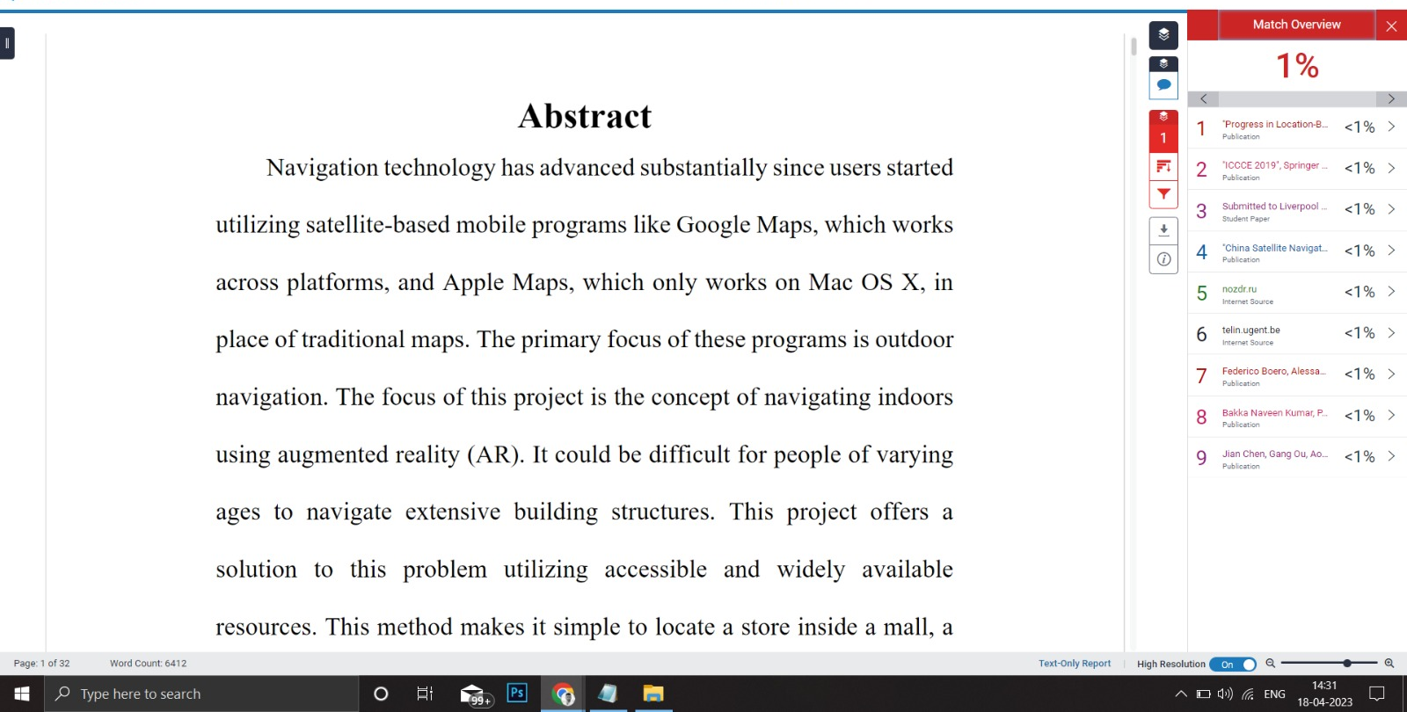

12. PUBLICATIONS

